To: UWG Employees
From: Dan Lewis
Date: June 26, 2017
Subject: The New OneUSG Connect – Benefits Website and Call Center

Beginning at 1:00 p.m. today, you will have two new ways to connect with your benefits - online and by phone. Following, please find the instructions:

- Online

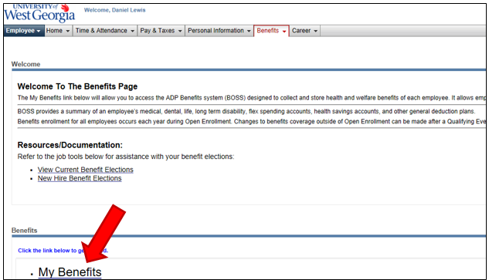
- From ADP: You may access to the OneUSG Connect – Benefits website the way you have always done it by entering the ADP portal, select the Benefits tab, and click the MY Benefits link:

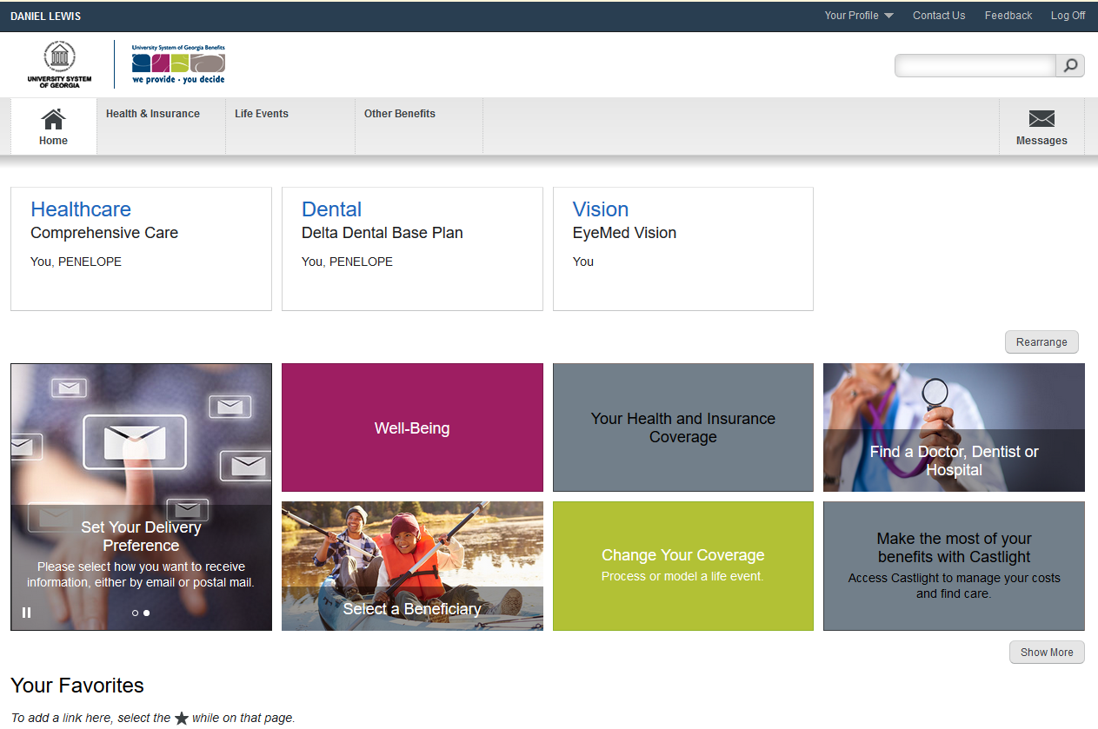
Once accessed, you will be able to review your benefits on this page by clicking the respective titles:

- OneUSG Connect Website: Another way to access the OneUSG Connect – Benefits via the Manage My Benefits links in the new USG Faculty and Staff portal at http://OneUSGConnect.usg.edu.
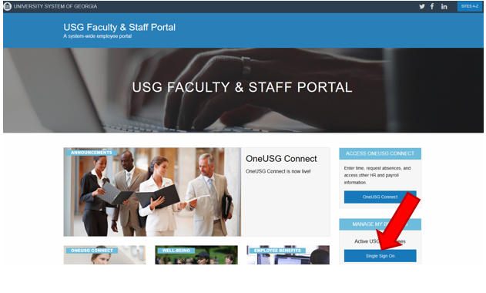

Click on the Single Sign On button and it will take you to the following page. Click on the UWG icon
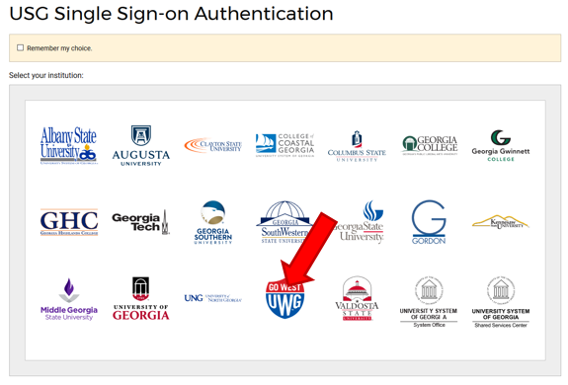

Type in your UWG ID and Password and click the Sign In button:
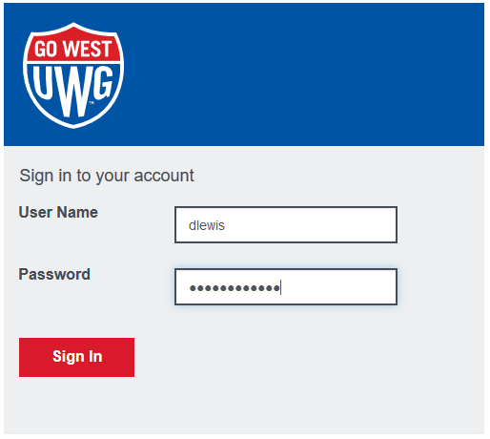
You will be able to review your benefits by clicking the respective titles:

During your first visit to the new OneUSG Connect – Benefits website, please:
- Review and confirm your contact information, dependents and beneficiaries.
- Explore the resources and features, since they will help you understand and make the most of your USG benefits.

- By Phone
Employees and retirees may reach the OneUSG Connect – Benefits Call Center toll free by calling:
1-844-5-USGBEN (1-844-587-4236)

Even though you now have two new ways to access your benefits, your benefits are not changing. (As always, you can change your benefits when you experience a qualifying life event, as well as during the next annual benefits Open Enrollment period in Fall 2017.)

Should you have any questions or concerns regarding this process, please contact the following UWG or USG representatives:

Holly Mostrom Benefits Administrator hmostrom@westga.edu 678-839-6338
Terri Bussey Business Partner tbussey@westga.edu 678-839-6413
USG Shared Services 1-855-214-2644

Thank you for your cooperation.

Dan

Dan Lewis
OneUSG Connect Change Lead for UWG
678-839-4781

