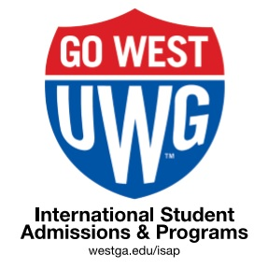

January 2021 Newsletter
Published monthly by International Student Admissions and Programs (ISAP) to provide reminders about
immigration regulations, services, programs, and opportunities for involvement.

CONTENTS:
- Important Deadlines & Reminders
- Health Insurance Waiver Process
- Enrollment Requirements & UWG Student Code of Conduct
- Make Friends | Get Involved |
- Tax Season 2021
- Georgia International Leadership Conference (GILC)
- International Festival 2021
- ISAP Events
- Campus Jobs
- MLK National Holiday, Jan. 20th
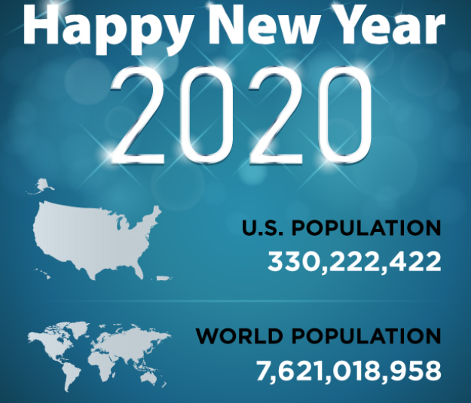
- Follow ISAP on Instagram | Contact ISAP
Hello and Happy New Year!
ISAP and UWG are excited to welcome 39 new international students from 8 countries:
Korea, Brasil, France, Gabon, Pakistan, Nigeria,
For those of you returning to UWG after your break, welcome back. A great semester and year are ahead!
You are WELCOME here!

REMINDERS
- FULL-TIME ENROLLMENT REQUIRED BY: January 9th, 11:59pm. Enrollment options for Spring 2021 will be a continuation of Fall 2020 modifications regarding on-campus, on-line and remote. Undergraduate - 12 credit hours. Graduates - 9 credit hours. No exceptions. Reduced Course Load (RCL) Required. Details HERE
- DROP / ADD: Deadline to drop or add a course to your schedule is January 15th 11:59pm

- REDUCED COURSE LOAD (RCL): If this is your final semester, or you have a valid medical reason to be under-enrolled, the deadline to request an RCL is: January 15th, 5pm.

- FEE PAYMENT DEADLINE: The payment deadline for tuition and fees is January 19th, 11:59pm. After this date, your enrollment could be automatically dropped if not paid in full.

- HEALTH INSURANCE WAIVER DEADLINE: January 22th at 5pm. Be Aware: See next topic below.

- SEVIS REGISTRATION TO “ACTIVE” & GEORGIA DRIVERS LICENSE: All new and returning students are now in the process of being registered to “continued attendance” in SEVIS for Spring semester 2021. If you wish to apply for a Georgia Driver License (DL), you may do so next week. Details are HERE.

- CURRICULAR PRACTICAL TRAINING (CPT) APPLICATIONS: CPT is a temporary work authorization for off campus internships in your field of study. The deadline to apply for Spring 2021 CPT is Friday, January 15th at 4pm. Details are HERE.

DEADLINE: SPRING 2021 HEALTH INSURANCE WAIVERS: JAN. 22, 2021
If you wish to waive out of UWG insurance for Spring + Summer semester 2021, you must first enroll and activate your insurance before you can request a waiver by January 22, 2021. Coverage begins January 1, 2021 and ends July 31, 2021.
Note: Waivers can take 2-4 business days to update on your bill.
Q: Where are the waiver portal and requirement details?
A: Please see: https://www.westga.edu/academics/isap/healthinsurance.php but also note that ISAP is not involved in the waiver process and has no way to appeal the UHC decision.

Q: What if there is no insurance charge on my account, but I’m enrolled in classes?
A: Please email Paul Sargent psargent@westga.edu as soon as possible to verify your location, enrollment and proper coding or eligibility for a waiver based on non-US location.

Q: What if I don’t have USG approved coverage by the fee payment deadline?
A: Your course enrollment will automatically be dropped by UWG as required by the USG. ISAP is not involved.

Q: What if I am fully enrolled OUTSIDE the U.S for Spring 2021?
A: Fill out the following form to certify your non-U.S. location for removal of the charge. https://www.cognitoforms.com/UniversityOfWestGeorgia1/OutofCountryInsuranceWaiverRequest

Q: Can ISAP help me find insurance that meets the USG / UHC waiver requirements?
A: Unfortunately, no. ISAP is not aware of any plans that meet the waiver requirements outside UHC plan.

Q: My waiver was denied but I think my plan is acceptable. How can I appeal?
A: Please email: ship@usg.edu with your full name, institution name and a brief summary. ISAP is not involved in the process.

UWG STUDENT CODE OF CONDUCT >> online here
Please be reminded:
- The legal drinking age in the US is 21 years old. When you enter a bar or place that sells alcohol, you will be asked for photo ID ( DL or passport). If you are under the age of 21 you will not be served or allowed to buy alcohol.
- Possession, use or distribution of pot in any form is illegal in Georgia and in the US, despite being legal in some states.
- In Georgia, this is a "misdemeanor" (lower category) crime, with a possible fine of $1000 or a year in jail. O.C.G.A. §16-13-2(b)
- A criminal conviction, including D.W.I. (Driving While Intoxicated) can lead to visa revocation and a 10-year travel ban to the U.S.

We encourage you to think wisely about your choices.

MAKE FRIENDS | GET INVOLVED
The best way to meet new people, improve your English and be successful in the U.S. is to make friends. The best way to make American friends is to get involved in a campus organization!
Pick an interest, sign up, show up and say hello! It’s that simple.
- List of 150+ student organization at UWG is HERE
- To sign up, register in “Wolf Connect” HERE

TAX INFORMATION 2021 (FOR TAX YEAR 2020)
ISAP will provide information about U.S. Federal and State of Georgia Tax Returns each Spring ahead of the tax-filing deadline: April 15th, 2021.

What you need to know now is:

- DON’T BUY Tax Prep Software: like TurboTax, H&R Block or any others! They were not designed for “Non-Resident” tax forms.
- ISAP will provide free access to special software called in February for your Non-Resident Federal Tax Returns.
- Everyone has at least 1 federal tax form to complete, unless you arrived in the U.S. in 2019. In that case there are no forms to complete this year.
- For more info on this process, click HERE.

Do I need to file taxes?
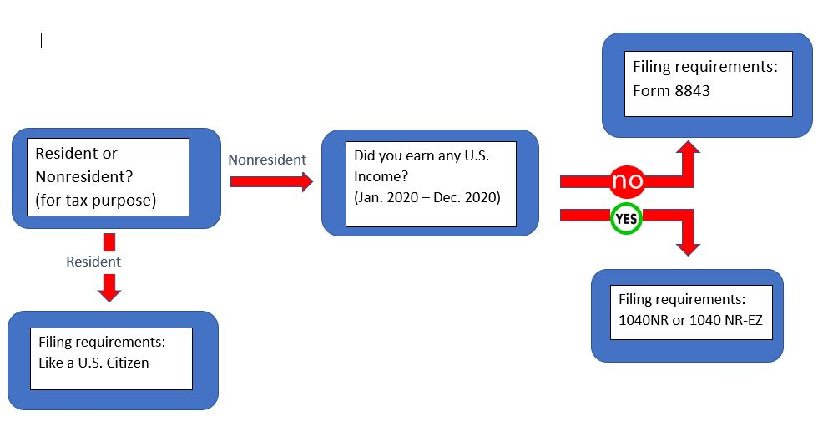
*ISAP does NOT provide tax advice or tax preparation assistance, only general guidance!

2021 GEORGIA INTERNATIONAL LEADERSHIP CONFERENCE (GILC)
What: GILC happens each spring. It’s a college student conference for international students and study abroad students from across Georgia over 1 weekend. Participants share ideas, network and above all, develop their leadership qualities and have fun!
Dates: March 5 – 6th 2021
Location: VIRTUAL
Cost: $5.00
Details: More details about GILC are HERE.
To Apply: Registration Opens Jan.20th. But in the meantime, do the following steps:
STEP 1: Email Rashika Webb at rashikaw@westga.edu expressing your willingness to commit to the conference.
Include your full name, 917, and major of study in your email!
STEP 2: Register using the customized link sent to you from GILC - Coming soon!
STEP 3: Review the GILC Student Checklist

INTERNATIONAL FESTIVAL 2021
ISAP needs your talent, flair and help! The pandemic cannot stop the International Festival planning team as we present International Festival 2021: Olympic Games! There will be a parade of flags, Olympic game activities and more!

When:
Where:

Got a sport from your home country that you would like to demonstrate to your fellow students? Or interested in carrying a flag for the parade?

To sign up to participate or volunteer, email: rashikaw@westga.edu be sure to include your 917
- For flag carriers: include the country of the flag you want to carry!
- Demonstrating sport: include the type of sport and the activity you plan to do.

SPRING SEMESTER CAMPUS EMPLOYMENT
- F1 & J1 students may be employed in non-federal work study jobs on
campus up to 20hrs per week.
- J1 students must request employment authorization from ISAP.
- All employment requires application for a free Social Security Card.
- Instructions for the SSN application are here >> Intl Student Employment
- UWG campus jobs are listed on this webpage >> Jobs at UWG
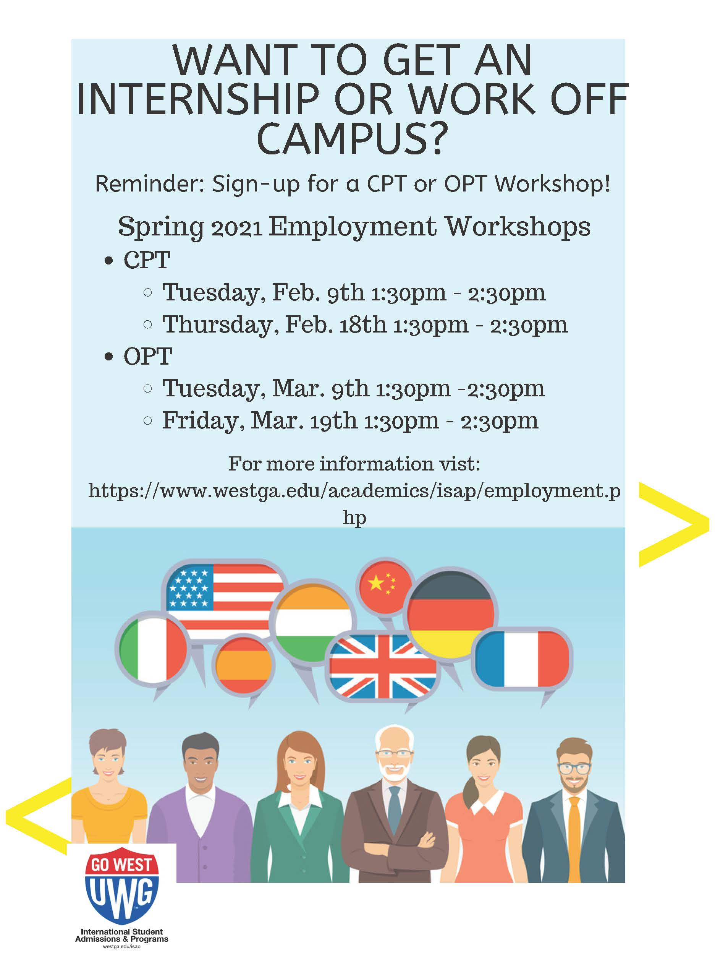

SOCIAL SECURITY CARDS
If you have a job offer or Georgia Driver’s License and need to apply for a US social security #, you will need to arrange your own transportation or reserve a ride via “Carroll Connection” at: 844-778-7826 or utilize other transportation services such as Lyft or Uber.

NATIONAL HOLIDAY
University of West Georgia will be closed: Monday, January 20th, 2021 in honor of Martin Luther King, Jr. Day. UWG will celebrate MLK on Monday, Jan. 20th, 7pm in the Campus Center Ballroom. All are invited.
- UWG MLK Celebration details are HERE.
- More information on the legacy of MLK Jr. is HERE .

ISAP EVENTS
How do I sign up for these events?
You register in “Wolf Connect” HERE. No emails will be accepted as signing up for events.

CONNECT WITH ISAP
- ISAP on IG | Click the Logo |
- International Student Admissions & Programs (ISAP) @ UWG
Mandeville Hall | Front Campus Drive
www.westga.edu/isap | T: 678-839-4780
- Live Chat during regular office hours M-F from our home page above
- Email Us from the ISAP Staff Directory
Include your 917 and full name
- No Walk-in Advising until further notice.
- COVID-19 Safety Reminders

