Purchasing Card
(P-Card)
Manual

Approved 1/16/08
Rev 1.0 2/20/08
Rev 1.1 3/14/08
Rev 2.1 8/14/09
Rev 3.1 10/2/12
Rev 3.2 6/20/13
Table of Contents
Important Contact Information & Instructions 1

Overview 2

Definition of Purchasing Card (P-Card) 2

Who Can Get a P-Card? 3

How Do I get a P-Card and Keep It? 3
Complete the P-Card Application
Attend a P-Card Training Session
Sign the P-Card Agreement Form Upon Card Receipt
Complete Refresher Training Yearly

Changes to P-Card Information 4

Spending Limits, Controls & Guidelines 4
P-Card Controls
Cardholder Spending Limits
Merchant Activity Type Limits
Splitting Orders
Security Issues
Pickup or Delivery of Ordered Products
Team Travel & Studies Abroad Information
Year End Deadlines

Allowable Purchases (Things I CAN buy with a P-Card) 6

Prohibited Purchases (Things I CANNOT buy with a P-Card) 7

Responsibilities of Department Roles within the P-Card Program 8

How to Make a Purchase with Your P-Card 10
Approval Procedure
Place Order with Vendor
Sales Tax Exemption
Maintain Paperwork for Monthly Reconciliation

Resolving Errors and Disputes 11

Monthly Reconciliation of Billing Statements 12

Purchasing Card Violations 12

Review of P-Card Transactions 14

Provisions for Review 15

Forms
Appendix A – P-Card Application
Appendix B – P-Card Agreement Form
Appendix C – Bank of America Dispute Form
Appendix D – P-Card Account Summary
Appendix E – P-Card Transaction Log
Appendix F – SA & TT P-Card Account Summary (Should be used only for pre-approved Team Travel & Studies Abroad P-Cards)
Appendix G – Ethical Statement of Values
Appendix H – Guidelines for Interpreting Consumer Credit Checks
Appendix I – Authorization Form for Consumer Reports

Important Contact Information & Instructions

To Report Lost or Stolen Card or Fraud:
888-449-2273 (Bank of America, Business Card Services)
(Also contact P-Card Administrator)

P-Card Administrator:

Jeanna Lambert 678-839-5536, jlambert@westga.edu

In the event that you cannot reach the P-Card Administrator, please contact Assistant Director of Purchasing:

Shelly Parker 678-839-6398, sparker@westga.edu

Procurement Website: www.westga.edu/purchasing

UWG’s Federal Identification Number: 58-6002055

Tax Exemption Certificate: http://www.westga.edu/assetsDept/purchasing/sales_tax.pdf

When placing orders online or by phone:

The billing address for all P-Cards is: University of West Georgia
Attn: Cardholder Name/Dept. Name
1601 Maple Street
Carrollton, GA 30118

The billing phone # is: 678-839-6398

The shipping address for all P-Cards is: University of West Georgia
Central Warehouse
Attn: Cardholder Name/Dept. Name

Compliance
The UWG P-Card Policy is in compliance with the State Purchasing Card Policy. In the case of conflicting language between this policy and other written policies the following is the order of control: State law, State Purchasing Card Policy, Board of Regents Policy, UWG policy.

Use of the Purchasing Card for Personal Purchases Prohibited
Under no circumstances is a cardholder or program participant permitted to use the P-Card or related accounts for personal purchases. Using the P-Card for personal purchases may result in disciplinary action, up to and including termination from State employment and criminal prosecution. The Official Code of Georgia, Annotated (O.C.G.A.), § 50-5-80 states that any person who knowingly uses state funds for personal purchases under $500 is guilty of a misdemeanor. A person who knowingly uses state funds for personal purchases of $500 or more is guilty of a felony punishable by one to 20 years in prison. Supervisors or other approving officials who knowingly, or through willful neglect, approve personal or fraudulent purchases are subject to the same disciplinary actions as those making the purchases.

Source: Statewide Purchasing Card Policy, July 2012

Overview
This manual has been developed to provide a step-by-step guide for use of the card, to document the State of Georgia Purchasing Card Program activity, and to provide instructions for reconciliation and review of the transactions.

Definition of a Cardholder
Cardholders and approving officials are designated as State Purchasing Agents and are subject to the provisions of O.C.G.A. § 45-10-1 et seq. regarding State Employee Code of Ethics and Conflicts of Interest. Purchasing Services reserves the right to set the minimum number of P-Cards to be issued to cost centers in order to ensure that University business is done in a reasonable and cost productive manner.

Definition of a Purchasing Card (P-Card)
The State of Georgia Purchasing Card, hereafter referred to as the P-Card, is the property of the State of Georgia and is only to be used for State business purposes. It should be viewed as an additional tool for approved expenses to buy products and services which are more efficiently bought by a purchasing card, or to buy from vendors who routinely only do business via credit cards or cash. Using the system will reduce the time and paperwork normally associated with these types of purchases.

Although the card is issued in an individual’s name, it does not affect personal credit in any way, nor shall it be used for personal purchases.

Who Can Get a P-Card?
Permanent full-time or part-time employees of the University of West Georgia, whose position and job responsibilities requires the purchase of items and services, may be eligible for purchasing card privileges. Neither student employees nor casual labor are eligible for a P-Card. Prospective cardholders must undergo a criminal background check and credit check prior to the issuance of a P-Card.

How Do I get a P-Card and Keep It?
Before a request for card is made, the manual must be read in its entirety by the proposed cardholder. A P-Card can be obtained by completing the following steps:
- Complete the P-Card Application (Appendix A) – The form must be signed by the Cardholder and the Department Head and/or Supervisor.
- Read and sign the “Ethical Statement of Values” form (Appendix G) – The form must be signed by the Cardholder and the Department Head and/or Supervisor.
- Complete and sign criminal background and/or credit check release form.
- Attend a P-Card Training Session – Training is mandatory for all P-Card roles: Cardholder and Department Head and/or Supervisor. Cards will not be disbursed until training has been completed.
- Sign the P-Card Agreement Form upon Card Receipt (Appendix B) – This form will be presented to the Cardholder for signature upon receipt of P-Card. Appendix B is included in this manual for informational purposes only and should not be completed by the Cardholder prior to receiving their P-Card or prior to attending training. Procurement will provide the P-Card Agreement Form for signature when you receive your P-Card. By signing this form, the Cardholder acknowledges:
  - Receipt and understanding of the regulations for use and protection of the P-Card.
  - Understanding of responsibilities in the reconciliation process and billing disputes.
  - Understanding and acceptance of consequences of P-Card violations.
Upon receipt of the P-Card, please confirm that it is issued in your name and sign the back of the card in ink.
- Complete Refresher Training Yearly – P-Card “Refresher” Training is required yearly. The Cardholder and Department Head and/or Supervisor will be required to complete a refresher training session in order to maintain P-Card privileges.
- A cardholder whose P-Card is not used during a consecutive 6 month period will have their card suspended.

Changes to P-Card Information
The P-Card Change Request Form (Appendix A) should be completed if:

- The cardholder’s name or information changes
- The cardholder’s department changes
- The spend limits are increased or decreased

If the cardholder changes department or positions, or leaves employment of UWG, the P-Card Administrator must be notified by the Supervisor immediately and the card must be returned for cancelation

P-Card Controls
Since the University of West Georgia, not the individual employee, will pay for the purchases made with the P-Card, controls have been added to the P-Card accounts. These limits are imposed at the point of sale when the card is used.

Cardholder Spending Limits
The available limits on a P-Card include:

- Single Transaction Limit - per transaction limit
- Credit Limit – monthly spend limit

The University’s standard limit on P-Card purchases is $1,000 per transaction and $5,000 per month. Please note that the monthly limit is refreshed at the beginning of the billing cycle (the 5th of each month).

If an increase or decrease in the per transaction limit or monthly credit limit is required, please complete the P-Card Change Request Form (Appendix A). This form must be signed by the Department Head/Supervisor of your respective area. The P-Card Administrator will review the justification and make a determination on the increase within State guidelines based on departmental needs and requirements.

Merchant Activity Type Limits
Specific types of businesses are identified by a Standard Industrial Classification (SIC) code. This is commonly referred to as a Merchant Category Code (MCC) and P-Card transactions are restricted based on these MCC Codes. If you have difficulty using your P-Card with a particular vendor, please contact your P-Card Administrator for further information. Please note that the MCC Code is set by the merchant’s or vendor’s merchant bank, not UWG.

Splitting Orders
The practice of splitting a large order into two or more orders, as well as purchasing the same items from two or more vendors may be considered an attempt to evade the limitations of the P-Card and may lead to revocation of an individual’s P-Card privileges. If the value of a project, product or service exceeds $25,000 within a fiscal year, Purchasing Services should be contacted and the need for a bid should be reviewed.

Security Issues
P-Cards should not be shared with anyone, including your supervisor. The P-Card is issued to an individual and only that individual can use the card. The P-Card, P-Card number and all transactions should be kept secure at all times. Only the cardholder may place the order by telephone, fax or on-line.

Pickup or Delivery of Ordered Products
It is acceptable for a phone order to be picked up by another individual other than the cardholder as long as the recipient does not have knowledge of the card number.

Team Travel & Studies Abroad
The P-Card has been approved to pay for operating expenses and supplies associated with the student portion of Study Abroad and Team Travel Programs. The P-Card can only be utilized for the expenses of the student members of the group or team including payment for student food, lodging, travel and upfront expenses for the student only prior to the trip. In the case of Study Abroad, it can also be used to pay for entrance to tourist venues of an educational nature.

No employee or non-student expenses may be paid using the P-Card. ^{[1]} For information related to employees and non-students, please refer to UWG’s Travel website http://www.westga.edu/travel/index_2987.php or contact the Office of the Controller @ ext. 96390.

^{[1]} Violation of this policy is a reportable offense to the Office of Internal Audits, Board of Regents

The standard limits of $5,000 per transaction and $10,000 per month are allowed for Team Travel and Studies Abroad P-Cards. If these amounts need to be changed, Appendix A should be completed and submitted to P-Card Administrator.

Prior to utilizing the P-Card for one of these programs, the following should occur:

- An encumbered and approved travel authorization should be on file.
- A one-time approval from P-Card Administrator to utilize your P-Card for Team Travel (please email jlambert@westga.edu)

The following information should be submitted with the statement each month:

- P-Card Account Summary Form (SA&TT)(Appendix F)
- Original Receipts
- If food is purchased include: Food Purchased with Institutional Funds Form http://www.westga.edu/assetsDept/controller/Food_Purchase_with_Institutional_Funds_form_rv4.pdf
- Student Roster
- Trip Itinerary
- If business purpose of expense is questionable, please include explanation w/receipt

Year End Deadlines
In approaching year end deadlines, be aware all charges must be posted to the P-Card no later than June 4th. The post date is the date that the charge is incurred by Bank of America, not the date that the charge is issued so be sure that any charge made close to this timeline is considered. Any charges posted after June 4th will result in charges being incurred to the next fiscal year.

Allowable Purchases (Things I CAN buy with a P-Card)
The P-Card is to be used to purchase supplies, goods or services solely for State business purposes. Some allowable items include but are not limited to:

- Advertising (Please attach an ad or copy of the job announcement as documentation)
- Books, Magazines & Subscriptions (for no more than 1 year)
- Bookstore Purchases – (excluding otherwise prohibited purchases)
- Professional Dues & Memberships (excluding Chamber of Commerce)
- Professional Licenses
- Supplies (Generally associated with requirements of job duties.)
- Paper or Toner purchased from Staples
- State Contract Items – Documentation should include contract number
- Repairs & Maintenance
- Rentals – non transportation
- Software – Excluding software that interfaces with UWG systems or requires signing a contract or otherwise agreeing to terms of use
- Non-Inventory Equipment (less than $1,000.00)
- Declared Emergencies and Natural Disasters – Contact P-Card Administrator for permission and guidance – Requires submission of SPD Emergency Purchase Form within 72 hours

- Student Activity Funds Only:
  - Food/Drink – Food and drink is allowed on the P-Card for Student Activities accounts; however, approval by the P-Card Administrator and the respective department Vice President on a fiscal year basis is required. Additionally, this approval is for students only and no food/drink shall be consumed by employees of the University. If the activity is not open to the entire student body (e.g. athletic teams, student clubs) additional documentation is required:
    - Roster of participants showing the name and signature of each student
    - Itemized receipt
    - Copy of the team schedule or other documentation showing that the meal was an authorized student activity.
    - Food purchased with institutional Funds form: http://www.westga.edu/assetsDept/controller/Food_Purchase_with_Institutional_Funds_form_rv4.pdf
- Team Travel & Studies Abroad – See Team Travel & Studies Abroad section on Page 5.

Prohibited Purchases (This I CANNOT Buy with a P-Card)
Prohibited by State and BOR Policy (These are reportable offenses)

- Personal purchases of any kind to include items for workplace. (i.e. coffee pots, holiday decorations, greeting cards, office décor)
- Data plans, software, or applications for non-State Entity issued devices
- Gift Cards
- Cash Advances
- Foundation Account Purchases (Please review the foundation account purchase policy on the Purchasing Website: http://www.westga.edu/purchasing/index_2670.php
- Employee travel and entertainment expenses (Please review the policies on the UWG Travel Website: http://www.westga.edu/travel/ and submit paperwork through the proper travel procedures)
- Food/Drink (Exception is Student Activities and other pre-approved fund groups)
- Motor Vehicle Expenses including Gasoline, Repairs & Maintenance
- Memberships and/or fees to wholesale shopping clubs or “warehouse” type retailers
- Alcohol or tobacco products
- Firearms or explosives
- Professional services as listed in BMP Section 3.1.2 and O.C.G.A. § 14-7-2
- Split purchases to avoid Single or Monthly Transaction Limits
- Sales tax

Further Prohibited by UWG Purchasing Policy
- Conference/Seminar Registration Fees
- Hazardous or radioactive material (unless pre-approval is given by Risk Management)
- Computers & Laptops
- Rolling Stock (includes trailers, bush hogs, etc.)
- Inventory equipment ($1,000 or more)
- Transportation Rental

Responsibilities of Departmental Roles within the P-Card Program
Cardholder Responsibilities
When accepting the P-Card, the Cardholder becomes an authorized purchaser for the University with specific responsibilities for expending public funds. Cardholder responsibilities include, but are not limited to:

- Maintain security of account number, expiration date, and security code.
- Understanding of P-Card policies and guidelines.
- Using the P-Card for State business purposes only, not personal use.
- Self-report immediately to Purchasing Services any misuse of the card.
- Obtaining best value.
- Receiving and inspecting all ordered supplies and reporting discrepancies to the vendor.
- Obtaining, validating and reconciling all sales slips, register receipts and/or Purchasing Card slips and submitting appropriate paperwork to Department Head and/or Supervisor for approval. (Note: Cardholders must personally reimburse, within 30 days of the purchase, the institution for purchases made that are not appropriately documented. Approving officials may also be required to reimburse the institution if the approving official approved the purchase.)
- Documenting attempts to resolve disputes or billing errors directly with the vendor.
- Ensuring that an appropriate credit for the reported disputed item or billing error appears on a subsequent Cardholder Statement.
- Immediately reporting a lost or stolen card to Bank of America @ (888) 449-2273 (24 hours a day, 365 days a year). And at the first opportunity during normal business hours, immediately notifying the P-Card Administrator.
- Not accepting cash in lieu of a credit to the Purchasing Card account in the event of a refund for any reason.
- Limiting vendors that can be used. The Cardholder should use discretion in making P-Card purchases from relatives where the Cardholder has financial interest.
- Attending training.

Department Head and/or Supervisor responsibilities include, but are not limited to:
- Understanding of P-Card policy and guidelines.
- Initiating P-Card Applications.
- Ensuring review – The Department Head/Supervisor is responsible for ensuring that all P-Card charges are reviewed on a monthly basis for appropriateness. The individual conducting this review must sign the P-Card Account Summary Form to indicate that the review has been completed and that charges are appropriate as to the department and fund source. Complete information and documentation about the use, including all applicable receipts must be included. (Note: Cardholders must personally reimburse the institution, within 30 days of the purchase, for purchases made that are not appropriately documented. Approving officials may also be required to reimburse the institution if the approving official approved the purchase.)
- Providing notification to P-Card Administrator if employee leaves University employment or changes departments
- Immediately notify P-Card Administrator of suspected fraudulent activities or misuse.
- Attend training.
- Supervisors are limited to supervising no more than ten (10) P-Card holders. A waiver to allow more than 10 may be approved under special circumstances.

P-Card Administrator responsibilities are including, but not limited to:
- Interacting with Bank of America to assure compliance with the terms and conditions of the contract agreement.
- Determine which cost centers must use the purchasing card to achieve purchasing efficiency.
- Reviewing and evaluating for acceptance, purchase card applications from staff.
- Rectifying disputed charges, adding and deleting purchasing card users, establishing and adjusting control codes.
- Conducting P-Card orientation/training sessions for all new purchasing card recipients, including coordinating and conducting online refresher training.
- Maintaining a policy and procedures Manual for the P-Card Program.
- Reviewing and analyzing reports and statistical data to evaluate user activity and assure compliance with the policy and regulations.
- Reviewing annually all P-Cards issued to employees and eliminating P-Cards for employees who demonstrate consistently low usage of P-Cards or no longer have demonstrated business need for the P-Card.
- Serving as the point of contact for the University of West Georgia.
- Administering Works Software Program
- Notifying Cardholders and Department Heads and/or Supervisors of any changes to P-Card policy
- Reviewing monthly P-Card charges
- Reporting inappropriate charges to Cardholder and Department Head and/or Supervisor.
- Maintaining bank statements, receipts and related documentation by cardholder name & month.
- Signing the P-Card Account Summary, creating P-Card journal and submitting to Controller’s Office.
- Notifying Director of Purchasing, Controller and Internal Audit of suspected fraudulent activities.
- Notifying the Office of Internal Audit, Board of Regents, of any personal misuse of a P-Card.

Please note that due to internal audit controls, the P-Card Administrator is not allowed to obtain a P-Card.

How to Make Purchases with Your P-Card
Only the individual to whom the P-Card has been issued should use the card. When the decision to buy is made, the following procedures should be followed:

Approval Procedure
Proper internal departmental procedures in obtaining approval prior to the purchase should be followed. Once internal departmental procedures are obtained, be certain that the transaction is consistent with applicable rules for P-Card usage.
Place Order with Vendor
A P-Card may be charged by telephone, fax, online or in person. Be sure to inform the vendor that the purchase is for the State of Georgia to receive applicable discounts.

The University is tax exempt which means that we cannot be charged sales tax by vendors. In the event that sales tax is erroneously charged to your P-Card, the vendor must be contacted for credit immediately by the cardholder and documented on the receipt. A tax exempt form is available on our website: http://www.westga.edu/assetsDept/purchasing/sales_tax.pdf. If the vendor refuses to exempt Georgia state sales tax from the sale, the employee must stop the purchase process and nullify the purchase.

Be prepared to provide vendor with any or all of the following information:

- Card Number
- Card Name
- Expiration Date
- Billing Address
- Billing Phone Number
- Three Digit Security Code

The credit card security code is the last three digits located in the signature block of the card. Sometimes these three digits are referred to as the credit card verification code.

Inform supplier of the proper delivery and shipping instructions. The shipment should always be directed to:

University of West Georgia
Central Warehouse
Attn: Cardholder Name/Department
Carrollton, GA 30118

Maintain Paperwork for Monthly Reconciliation
All receipts and order documentation should be maintained to accompany the P-Card statement upon receipt. House Bill 1113 requires recording all transactions on the P-Card Transaction Log (Appendix E). The Transaction Log, and ongoing record of information about purchases, is an excellent form of record-keeping. Another reason to include a Transaction Log is to record any comments that are directly attributable to the purchase. The Transaction Log must list the account number for each transaction.

Resolving Errors and Disputes
The Cardholder is responsible for resolving disputes with the vendor such as incorrect pricing, delivery problems, incorrect items received, damaged items, paid taxes ^{[2]}, etc. When appropriate, one should ask the supplier to provide a credit to the P-Card account. Under no circumstances should there be a direct refund from suppliers for credit card transactions. If however, a direct refund is received in error, the refund check should be hand delivered to the P-Card Administrator immediately so that a reimbursement to the account is properly administered. Any communications should be documented and kept with the bank statement. Documentation should include dates, persons involved and a brief description of the problem.

In the event a solution cannot be achieved between the Cardholder and the vendor, Bank of America should be notified by faxing the dispute form (Appendix C). Dispute form should be faxed to 1-888-678-6046 within 60 days from the date of the original purchase. A copy of the dispute form should be sent to the P-Card Administrator along with the statement. Procurement may be called on for help in the event that Bank of America is unable to resolve the dispute.

^{[2]} Sales tax may be paid when required for vendors out of state

Monthly Reconciliation of Billing Statements
The Cardholder is responsible for ensuring that the monthly billing statement reconciliation is complete. Original receipts should be maintained during the month and included in the reconciliation process. An original receipt should be from the vendor and should indicate the details of the transaction. Packing slips, copies of shipping labels, etc. are not acceptable forms of receipt. If you have an issue receiving a receipt from the vendor or if you are missing a receipt, please contact the vendor for a copy and submit an explanation along with the Account Summary.

Step 1: Review bank statements and original receipts with detail of items purchased to verify appropriateness of items being purchased and funds being utilized.

Step 2: Complete and sign with original signature the P-Card Account Summary Form (Appendix C) for each department to show reconciliation has been completed. Identify and document any issues. The purpose of the purchase should be documented if questionable. If the receipt itself does not provide a clear understanding, please enter the purpose on the P-card Transaction Log (Appendix E) or write a note on the receipt that makes its use and appropriateness clear. Although the cardholder and approver may understand the purpose of purchase, it is also important for the P-Card Administrator and/or outside party if reviewed to understand the purpose of purchase as well.

Step 3: Submit P-Card Account Summary Form, bank statement, original receipts, Transaction Log and any documentation to Department Head and/or Supervisor for approval. Please note that an independent review of each P-Card transaction must be made by someone other than the cardholder, specifically a direct supervisor that has budgetary responsibility for the department. The department Head and/or Supervisor is responsible for ensuring that the cardholder has followed P-Card policy and signing the P-Card Account Summary as reviewed with original signature. (No stamped signatures or signatures by another individual will be accepted).

Step 4: Submit P-Card Account Summary Form, bank statement, original receipts, Transaction Log, any documentation and all appropriate signatures to P-Card Administrator for approval.

Purchasing Services will maintain all P-Card documentation in accordance with State of Georgia records retention policies.

Purchasing Card Violations
Orders should not be split to circumvent the open market limit of $25,000.00. Personal purchases are not allowed through the use of the P-Card. Prohibited purchases, and/or items purchased but receipt is missing, will be reviewed on a case by case basis. Items purchased may be returned for credit, or paid in full by personal check from the cardholder made payable to the University of West Georgia. Prohibited purchases may result in the loss of P-Card privileges. The Cardholder accepts the responsibility to ensure that items prohibited from purchase are not bought with the P-Card.

Violations of Policy
Violations of rules governing the use of P-Cards can be classified as minor or major. The suspension or revocation of the card is dependent upon the nature and frequency of the violation. Cardholders and Cardholder supervisors will be copied on all violations and supervisors will be consulted by the Purchasing Department before suspension or revocation occurs. Suspension or revocation actions cannot be overturned by the Cardholder or Cardholder Supervisor if the decision by the P-Card Administrator has been made. Internal Audit, Office of the Controller and the VP of Business & Finance will be notified of all major violations.

If it is determined by the P-Card Administrator that additional action should be taken to resolve the violation, the Cardholder, Cardholder Supervisor and Internal Audit will be notified of P-Card non-compliance and each department will proceed accordingly.

Personal misuse of the State’s purchasing card, whether inadvertent or intentionally, will result in the cardholder’s name being reported to the Office of Internal Audit at the Board of Regents. The University has no latitude in reporting misuse. In addition, purchasing items on such purchasing card that are not authorized for purchase by such employee is a reportable offense.

Minor Violations are instances that are accidental and without willful intent. A Cardholder will receive two warnings for minor violations. A third violation within a fiscal year will result in the loss of P-Card privileges for a suspension period of one month. Additional minor violations will be reviewed on a case by case basis and action will be taken for additional suspension or a revocation of P-Card privileges. In the case of minor violations, P-Card privileges can be revoked for up to one year, after which time, the Department Head may request re-issuance of the P-Card for the affected individual. Examples of minor violations include but are not limited to:

- Delinquent Monthly Reconciliations and Statements
- Improper purchases made that are unauthorized or restricted
- Purchasing outside of state contract
- Defensive or untimely responses to P-Card Administrator
- Undocumented sales tax charge errors (action not taken to credit)
- Missing receipts – Missing receipt form can be used three times during one fiscal year before suspension of account.

Major Violations indicate a willful intent to disregard P-Card program and State Purchasing rules. One major violation will result in loss of card privileges. Furthermore, the circumstances of the violation will be reported to the Office of Internal Audit, Board of Regents, for any additional action, which could include termination of employment and/or prosecution. Individuals whose violation results in the termination of their card will not be permitted to obtain another P-Card. In addition to Prohibited Purchases, examples of major violations include but are not limited to:

- Repetitive purchasing of unauthorized or restricted items
- Splitting orders to avoid the single transaction limit
- Allowing others to use the P-Card
- Knowingly and intentionally making personal purchases

Upon a major violation or revocation of P-Card privileges the following offices will be notified:

- Internal Audit
- Office of the Controller
- VP of Business & Finance
- Office of Internal Audit, Board of Regents

Review of P-Card Transactions
Department Head/Supervisor Review
The Department Head/Supervisor is responsible for ensuring that all P-Card charges are reviewed on a monthly basis for appropriateness as to Purchasing Policy and fund. The individual conducting this review must sign the P-Card Account Summary Form to attest that the review has been completed and that charges are appropriate to the department.

P-Card Administrator Review
The P-Card Administrator is responsible for ensuring that all P-Card charges are reviewed on a monthly basis to be in accordance with State Guidelines.

Controller’s Division Review
A P-Card journal will be submitted to the Controller’s Office on a monthly basis. Monthly statistics regarding P-Card compliance will be provided to the Controller and Internal Audit Division.

Internal Audit’s Review
Internal Audit will continue, as part of their regularly scheduled audit plan for departmental audits, to perform testing on P-Card compliance. Findings discovered by Internal Auditing will be covered in their audit reports and reported to Procurement and the Controller. The President, Vice President of Business & Finance, and the respective Vice President of area reviewed will be included in the distribution of audit findings. The Associate Vice Chancellor for Internal Audit at the Board of Regents level will also receive a copy of the report at the time of final distribution.
Provisions for Review
The Office of Purchasing Services will review this policy annually and make changes as necessary.

Legal Issues
- Failure to Comply with Laws, Policies, and Procedures
Cardholders or supervisors/approving officials who knowingly, or through willful neglect, fail to comply with the following may be subject to suspension or termination of card privileges or other disciplinary action, up to and including termination of employment and criminal prosecution to the fullest extent of the law.
- Official Code of Georgia, Annotated (O.C.G.A.), sections related to governmental purchasing
- Applicable requirements of the Georgia Procurement Manual
- State Purchasing Card Policy
- Internal policies and procedures governing procurement and the Purchasing Card Program.
The State Cards Program manager and State Purchasing Division reserve the right to withdraw any authority or delegated approval due to non-compliance with applicable laws, rules, regulations, policies, and procedures, or the terms of any conditional approval.
- Cardholder Background Checks
O.C.G.A. § 50-5-83(b)(12) requires criminal background checks on all employees hired for positions that are eligible for P-Cards.
- Cardholder Credit Checks
In addition to background checks for new and current cardholders, O.C.G.A. § 50-5-83(b)(12) also requires credit checks on all employees issued a purchasing card after July 1, 2008.

Appendix C
Appendix D
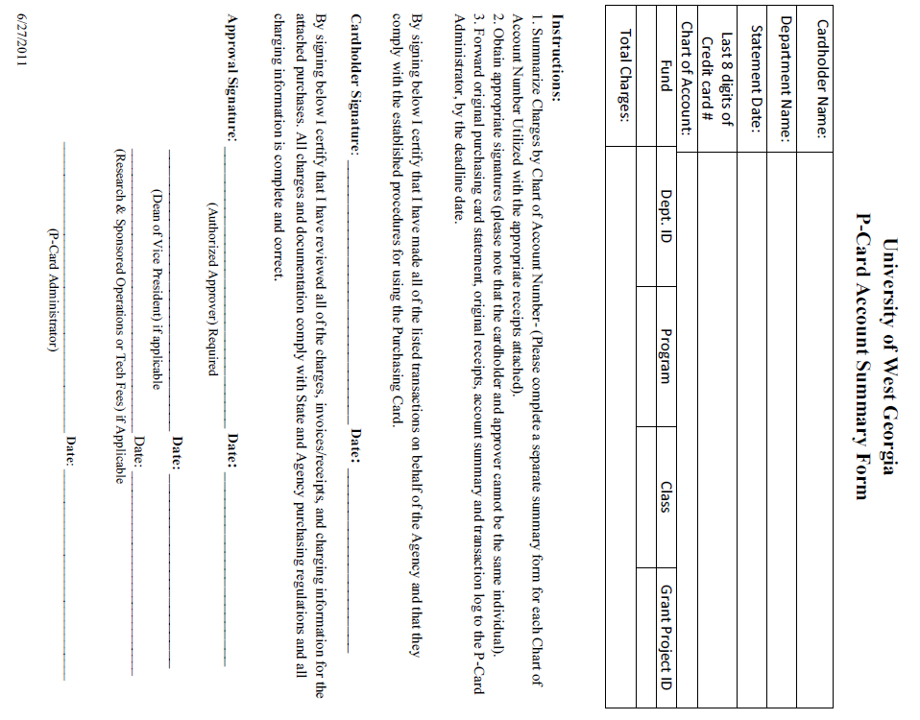
Appendix E
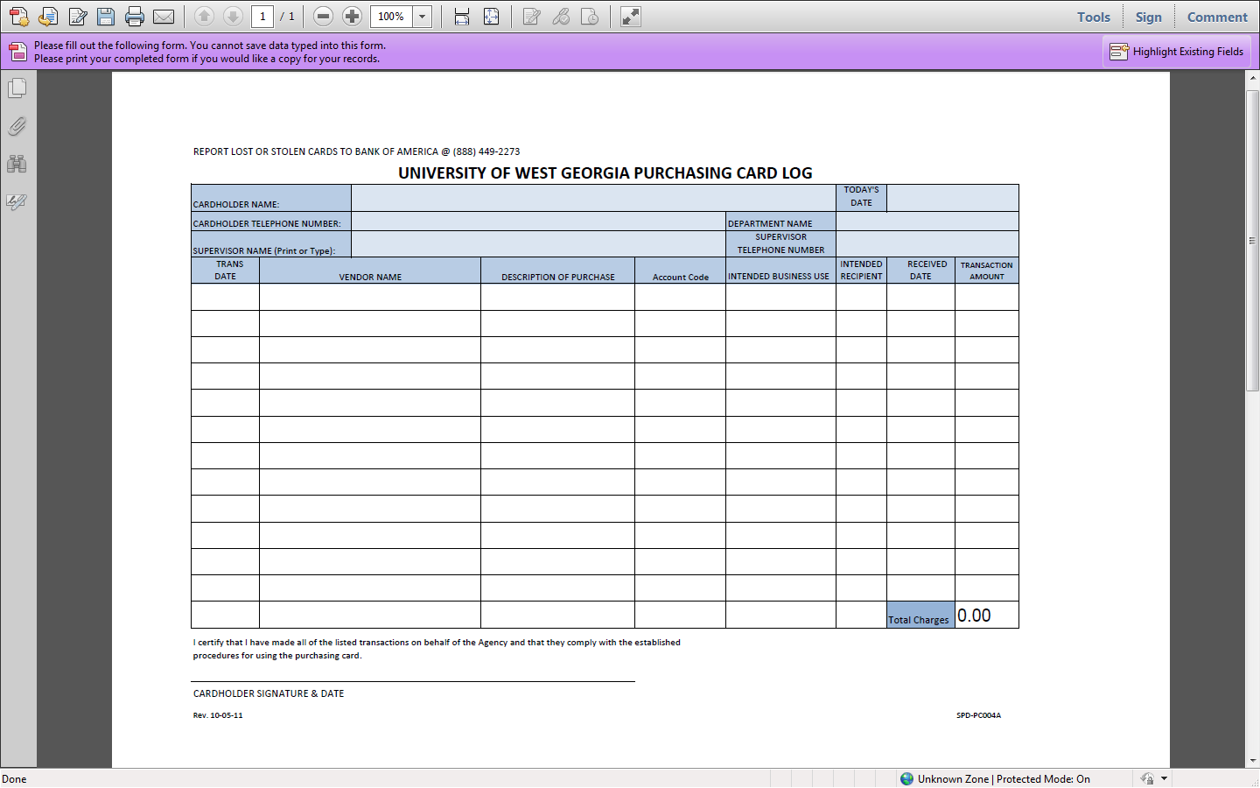

Appendix I

